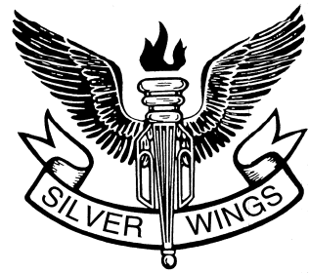
Silver Wings
Executive Management Center
AFA, Suite 400
1501 Lee Highway
Arlington, VA 22209

Award Endorsement Page

Number of pages in packet:

Endorsement:

Endorser Name: Title:
Signature: Date:

Endorsement:

Endorser Name: Title:
Signature: Date:

Attach additional copies as necessary to the Award Nomination. Endorsement may not exceed allotted space.

SW Form 20
19 Jan 2015

